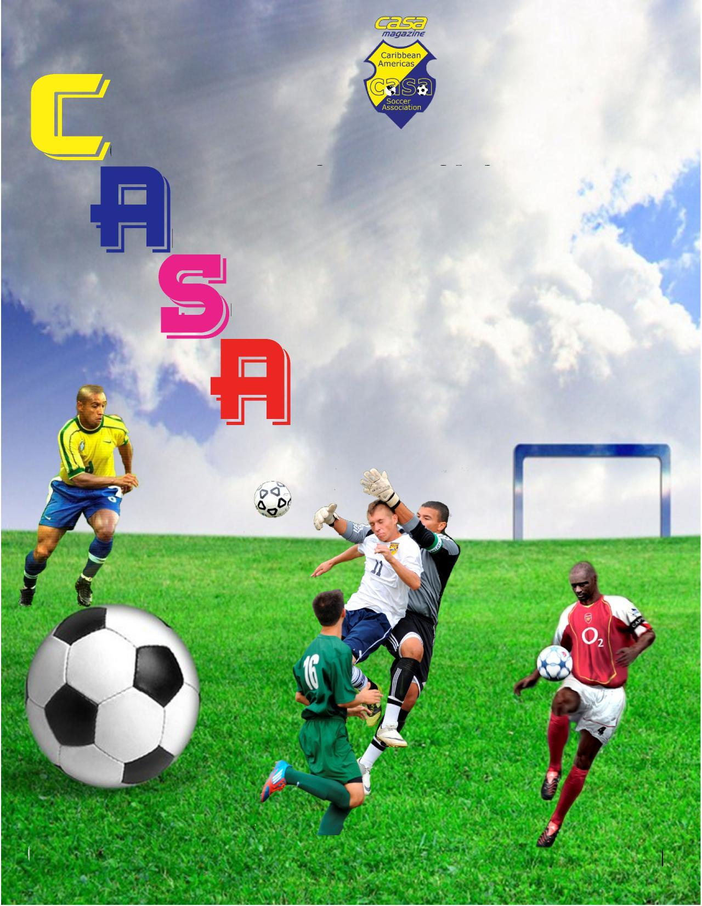

|  | **Caribbean Americas Soccer Association Phone: 786-383-1016 1860 North Pine Island Road, Suite 107 Fax: 754-200-8326**  **Plantation, FL 33322 Email:casa@casasoccerleague.com** |
| --- | --- |
|  |

YOUTH CLASSIC PACKAGE:

* Invitation letter
* Application and team registration
* Waiver
* Roster – General for **Referee**
* Roster – Summary Player Information for **Scouts**
* Player profile template
* Schedule (to be determined)

|  | **Caribbean Americas Soccer Association Phone: 786-383-1016 1860 North Pine Island Road, Suite 107 Fax: 754-200-8326**  **Plantation, FL 33322 Email:casa@casasoccerleague.com** |
| --- | --- |
|  |

October 16, 2022

Dear Coaches/Team Representatives:

The Caribbean Americas Soccer Association (C.A.S.A.) is excited to once again offer its Youth Classic event for the 2023 season. This event will kick off on January 17, 2023 and will culminate on Sunday, January 22, 2023 at the Lauderhill Sports Park in Lauderhill, Florida.

C.A.S.A. is a non- profit organization based in Lauderhill, Florida, and is affiliated with Florida State Soccer Association and United States Soccer Association. CASA’s Youth Classic supports our mission of introducing coaches and scouts to young soccer talents. Today, soccer is gaining more and more exposure in the United States, where the game is now attracting some of the biggest names with international recognition and unquestionable professional experience, most notably renowned soccer player David Beckham’s franchise Inter Miami CF.

Lauderhill, Florida, is located about nine miles North West of the Ft. Lauderdale/Hollywood International Airport and about twenty-two miles North of Miami International Airport. The Lauderhill Sports Park address is 7500 West Oakland Park Blvd., Lauderhill, FL 33319 and is easily accessible from Interstate 95, Florida Turnpike and Interstate 75 as well as local routes.

Join us for a great time of soccer where you will have an opportunity to expose your team to scouts. We look forward to hosting your team at our 2023 Youth Classic. Please do not hesitate to contact : Maxine Dwyer @ (754) 245-8396 or Munga Eketebi @ (786) 251-8077. **PLEASE NOTE :** Caribbean Americas Soccer Association will not responsible for any financial obligations incurred by any team participating in the Youth Classic.

Sincerely,

BOARD OF DIRECTORS

**Youth Classic**

C.A.S.A.’s youth soccer program (Youth Classic) further supports our mission by exposing these talents to Coaches/Scouts, thus, providing a one stop shop for soccer talents. Every January, C.A.S.A. in Partnership with The City of Lauderhill organizes a Youth Soccer Showcase at the Lauderhill Sports Park located in Lauderhill, Florida. This youth soccer event will facilitate Coaches/Scouts from all over the United States of America and from the rest of the world who come to evaluate players and their talents. **This tournament is open to boys ages 15-20 years old.** The six (6) day event is in a tournament format and gives team competitive games, while affording an opportunity to impress the Coaches/Scouts to acquire a 4 year college scholarship and get exposed to international professional soccer scouts. The outstanding plays and sportsmanship that characterize phenomenal soccer provide plenty of entertainment for the players and fans alike.

**CASA Youth Program**

C.A.S.A. Youth is designed to develop soccer skills for high school, college, and young men under the age of 23 years old, with the expectations to receive a 4 year college scholarship and get exposed to international professional scouts.

Other organized activities:

1. Provided scholarships for high school seniors to a four year college.
2. Partnership with cites, and other non-profit organizations within the community on various projects and other sports.
3. Production of an annual soccer sports magazine since 2005.
4. Provide support, assistance and partnership with the Lauderhill Netball program and participate in their fundraisers.
5. Arrange and promote soccer games in the community from local and international teams.
6. Entwine soccer, cricket and netball award ceremony.

|  | **Caribbean Americas Soccer Association Phone: 786-383-1016 1860 North Pine Island Road, Suite 107 Fax: 754-200-8326**  **Plantation, FL 33322 Email:casa@casasoccerleague.com** |
| --- | --- |
|  |

# **Application for CASA Youth Classic**

## ***NAME OF CLUB/TEAM___________________________________***

Please Print

## ***ADDRESS ______________ City ____________ State _____ Zip ___***

## ***CONTACT PERSON _______________ Position/Title _______________***

## ***PHONE#____________________E-MAIL ____________________***

***TEAM COLOR*** *1. _____________________________*

*2. _____________________________*

*________________________________ ___________________*

*Team Rep. Signature*

*________________________________ Date CASA Rep. Signature*

|  | **Caribbean Americas Soccer Association Phone: 786-383-1016 1860 North Pine Island Road, Suite 107 Fax: 754-200-8326**  **Plantation, FL 33322 Email:casa@casasoccerleague.com** |
| --- | --- |
|  |

**Caribbean Americas Soccer Association “CASA” - WAIVER FORM**

Every player (parent or guardian if the player is under the age of 18) must read and sign this Waiver Form. Signatures on this form signify that each person has read, understands and will abide by this information. There are risks associated with participating in this tournament and its related activities. We release and discharge CASA and/or the City of Lauderhill – Parks and Recreation, Broward County and any other approved venue or partner, Events Sponsors, Event Charities (collectively known as event organizers) and the workers, employees and Directors from all action, suits and demands. The event organizers are NOT responsible for any personal property by theft or otherwise. Permission may be granted for event organizers to record and or all of the participants in this event for photos, videos, motion pictures, TV, radios and other media, and to use them without any prior approval for publicity, promotions, advertising, trade or commercial or any other purposes without need for any reimbursement fee.

## ***TEAM NAME________________________________***

_______________________________ ______________________________

Print Player Name Player/Parent/Guardian Signature (if player if under 18)

_______________________________ ______________________________

Print Player Name Player/Parent/Guardian Signature (if player if under 18)

_______________________________ ______________________________

Print Player Name Player/Parent/Guardian Signature (if player if under 18)

_______________________________ ______________________________

Print Player Name Player/Parent/Guardian Signature (if player if under 18)

_______________________________ ______________________________

Print Player Name Player/Parent/Guardian Signature (if player if under 18)

_______________________________ ______________________________

Print Player Name Player/Parent/Guardian Signature (if player if under 18)

_____________________________ ______________________________

Print Player Name Player/Parent/Guardian Signature (if player if under 18)

_______________________________ ______________________________

Print Player Name Player/Parent/Guardian Signature (if player if under 18)

_______________________________ ______________________________

Print Player Name Player/Parent/Guardian Signature (if player if under 18)

_______________________________ ______________________________

Print Player Name Player/Parent/Guardian Signature (if player if under 18)

_______________________________ ______________________________

Print Player Name Player/Parent/Guardian Signature (if player if under 18)

_______________________________ ______________________________

Print Player Name Player/Parent/Guardian Signature (if player if under 18)

_______________________________ ______________________________

Print Player Name Player/Parent/Guardian Signature (if player if under 18)

_______________________________ ______________________________

Print Player Name Player/Parent/Guardian Signature (if player if under 18)

_______________________________ ______________________________

Print Player Name Player/Parent/Guardian Signature (if player if under 18)

_____________________________ ______________________________

Print Player Name Player/Parent/Guardian Signature (if player if under 18)

_______________________________ ______________________________

Print Player Name Player/Parent/Guardian Signature (if player if under 18)

_______________________________ ______________________________

Print Player Name Player/Parent/Guardian Signature (if player if under 18)

_______________________________ ______________________________

Print Player Name Player/Parent/Guardian Signature (if player if under 18)

_______________________________ ______________________________

Print Player Name Player/Parent/Guardian Signature (if player if under 18)

_______________________________ ______________________________

Print Player Name Player/Parent/Guardian Signature (if player if under 18)



| **Player**  **#** | **Name**  First Last | **Jersey**  **#** | **Player Signature** | **Goal** |
| --- | --- | --- | --- | --- |
| 1 |  |  |  |  |
| 2 |  |  |  |  |
| 3 |  |  |  |  |
| 4 |  |  |  |  |
| 5 |  |  |  |  |
| 6 |  |  |  |  |
| 7 |  |  |  |  |
| 8 |  |  |  |  |
| 9 |  |  |  |  |
| 10 |  |  |  |  |
| 11 |  |  |  |  |
| 12 |  |  |  |  |
| 13 |  |  |  |  |
| 14 |  |  |  |  |
| 15 |  |  |  |  |
| 16 |  |  |  |  |
| 17 |  |  |  |  |
| 18 |  |  |  |  |
| 19 |  |  |  |  |
| 20 |  |  |  |  |
| 21 |  |  |  |  |
| 22 |  |  |  |  |

NOTES:



| **Name:__________________________________**  DOB:_____________________________________  Age: _____________________________________  Position:__________________________________  Height: ___________________________________  Weight:___________________________________  Address:________________________________________  Email Address:___________________________________  TeL NO:_________________________________________ | | PHOTOGRAPH HERE  PHOTOGRAPH HERE  PHOTOGRAPH HERE | | --- | |
| --- | --- | --- |
| Grade Point Avg.:______________________ |  |
| SAT Score:____________________ |  |
| Academics (High School, etc.):______________________ | Graduation:______________ |
|  |  |
| **Soccer History:**  Team/Tournament:_______________________________  ________________________________________________  ________________________________________________  Prospective School:____________________________Major:__________________  Objective:________________________________________ | Date Played:_____________ |

**TEAM ROSTER – SUMMARY PLAYER INFO FOR SCOUTS**

**Name of Organization:______________________________**

**Phone:_________________ Email:_______________________________**

|  | **Christian Names** | **Middle Names** | **Surnames** | **Date of Birth** | **School** | **Position** | Contact Info |
| --- | --- | --- | --- | --- | --- | --- | --- |
| 1 |  |  |  |  |  |  |  |
| 2 |  |  |  |  |  |  |  |
| 3 |  |  |  |  |  |  |  |
| 4 |  |  |  |  |  |  |  |
| 5 |  |  |  |  |  |  |  |
| 6 |  |  |  |  |  |  |  |
| 7 |  |  |  |  |  |  |  |
| 8 |  |  |  |  |  |  |  |
| 9 |  |  |  |  |  |  |  |
| 10 |  |  |  |  |  |  |  |
| 11 |  |  |  |  |  |  |  |
| 12 |  |  |  |  |  |  |  |
| 13 |  |  |  |  |  |  |  |
| 14 |  |  |  |  |  |  |  |
| 15 |  |  |  |  |  |  |  |
| 16 |  |  |  |  |  |  |  |
| 17 |  |  |  |  |  |  |  |
| 18 |  |  |  |  |  |  |  |
| 19 |  |  |  |  |  |  |  |
| 20 |  |  |  |  |  |  |  |
| 21 |  |  |  |  |  |  |  |
| 22 |  |  |  |  |  |  |  |
| 23 |  |  |  |  |  |  |  |